Database reporting

Name of student

Name of professor

University

Course

Date

The first step is to organize the table into a database that will store the data. There are two tables are generated from this report and they include the products table and the orders table.

The products table looks like below:

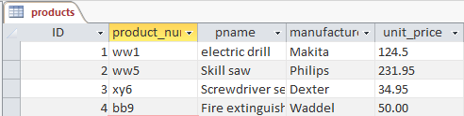

The orders table looks like below:

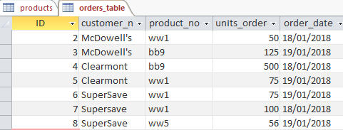

The next step is to generate reports from the above tables that can now be used for decision

Making purposes by the management. The preview of the two reports look like below;

The products report preview

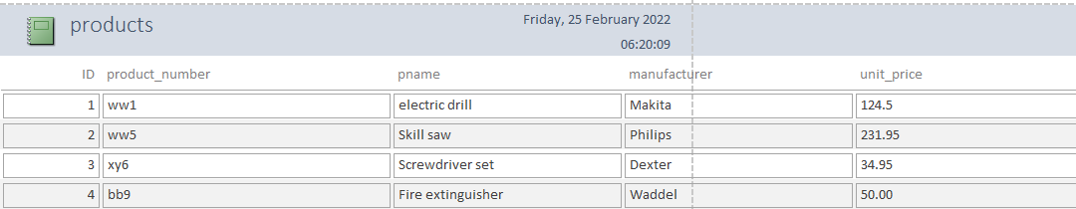

The orders report overview

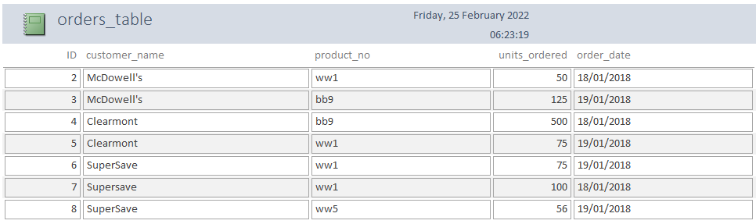

ii.) The reports indicate the date, the title of the report and the detail of each as required. Each report indicates the product name and its unit name. This kind of report is important in understanding the need to budget well by management by giving deep insights on the required amount to budget for the whole program.

b.) In this kind of reporting the hard data derived from this reporting will give strategic decision making members insights on:

I.) On how much of the products to buy

ii.) How much financial budget to allocate and use for this activity on purchase

iii.) Exact stock taking and allocation for the needed products

The soft data derived from this will give the top decision makers the opportunity to discuss the risks and opportunities associated with each budget allocation supposing a given choice to buy or contact the supply of the given products.

Reviewing the business process map for the above activity is analyzed and presented as follows;

|  |  |  |  |
| --- | --- | --- | --- |
| Activity | Gateway decision | Swim lane | Data Store |
| Need identification | Raise issues | Raise request | Mail touch point |
| Job description analysis | Role analysis | document | HRMS database |
| Advertise vacancy | Public advertisements | Advertise public | None |
| Accept applications | Applications acceptance | receive | Job portal DB |
| Review applications | HR review | review | None |
| Accept and reject | HR decisions | Review/accept | Job portal database |
| Schedule interviews | Interview | Interview and selection | None |
| Offer to candidate | Offering acceptance and rejection | Accept / reject offer | None |
| Candidate onboarding | Candidate onboarding | train | Employee database |

**Analysis and narrative:**

The recruitment process is a three step process that can be divided into three major groups that include role identification and vacancy announcement, interviews, and finally onboarding. These processes rely on the decisions that are made by the company as well as the employee. Each and every step involves an interaction with the system database, the Human resources database contains tables that store employee data, job applicant data, resume applications, cover letters as well as the status for each and every application.

Moreover, the database also contains the historical information of another job applications as well. During the hiring process, some of this data that can always be referenced to in making some of these critical decisions in the hiring process. Each and every decision made depends and relies on the previous decisions made. For instance, the HR cannot start accepting applications if no vacancy announcement has been made before to hire. During the whole process, data is manipulated and stored in the vacancy table, roles table, employee table and historical archival are updated as well.